1.INTRODUCTION

1.1 OVERVIEW

India’s Agriculture Crop Production Analysis (1997-2021).

1.2 PURPOSE

Crop production is a common agricultural practice followed by worldwide farmers to grow and produce crops to use as food and fibre. This practice includes all the feed sources that are required to maintain and produce crops .

2.PROBLEM DEFINITION & DESIGN THINKING

2.1 EMAPTHY MAP

|  |
| --- |
|  |
|  |  |

2.2. IDEATION & BRAINSTROMING MAP

|  |
| --- |
|  |
|  |  |

3.RESULT

Published India's agriculture crop production. It includes Climate changes, water scarcity ,Land scarcity, Economic crises.

DASHBOARD 1

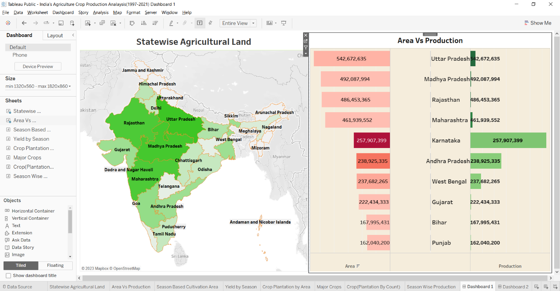

DASHBOARD 2

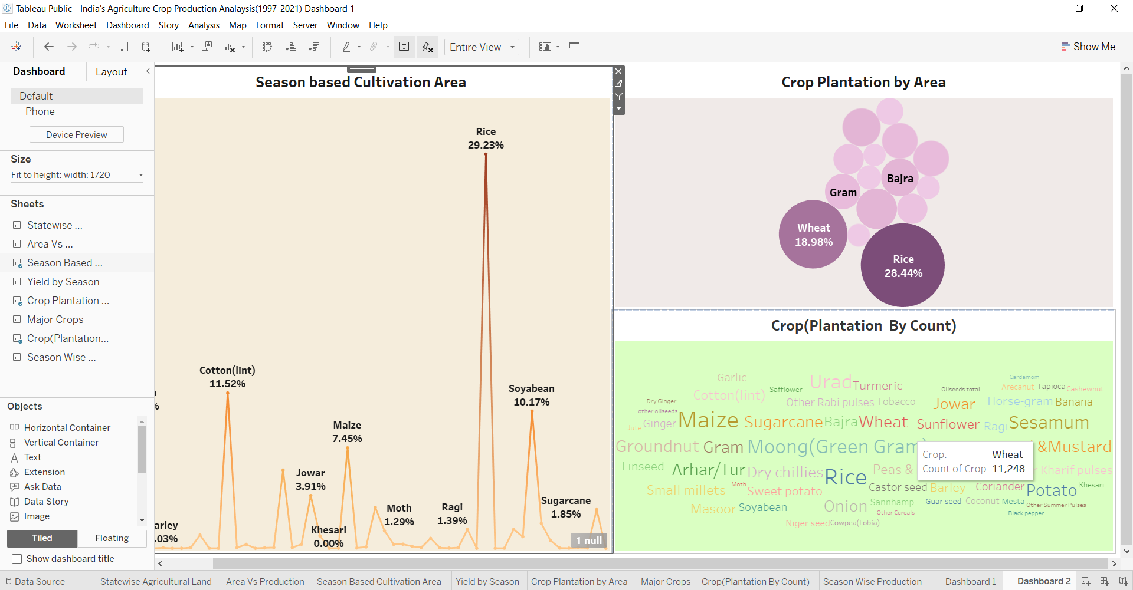

DASHBOARD 3

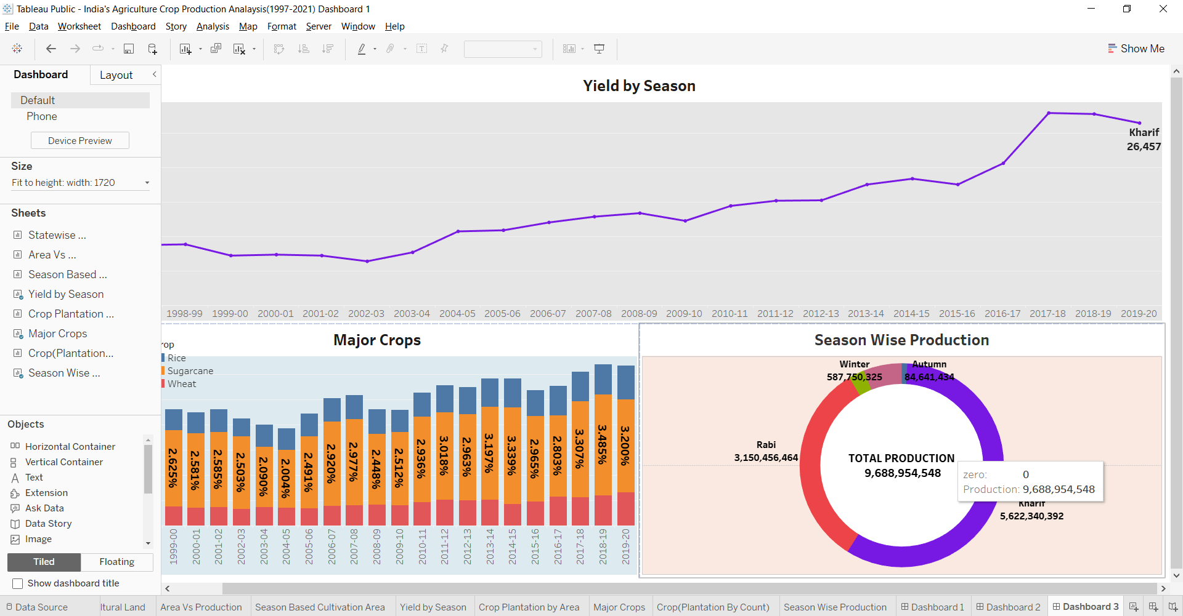

STORY

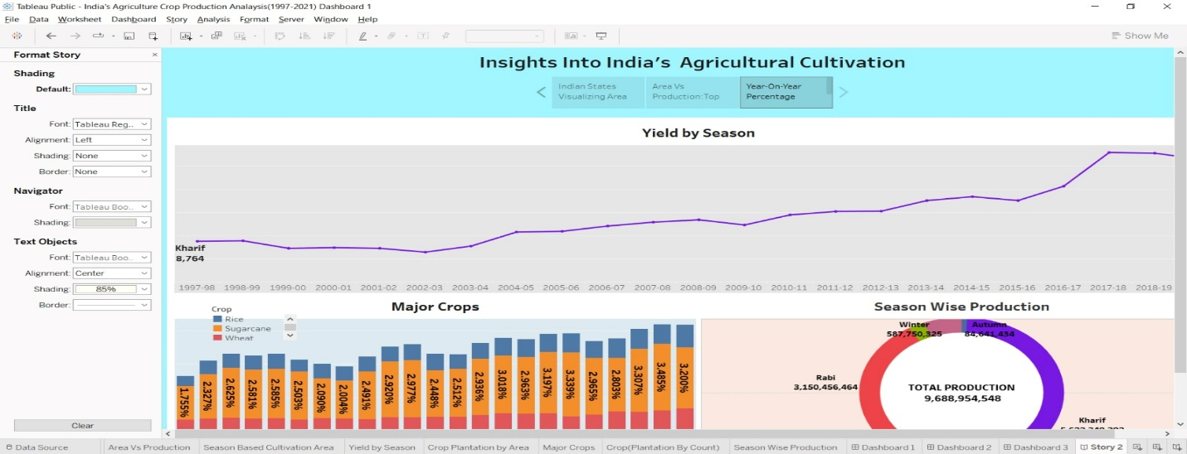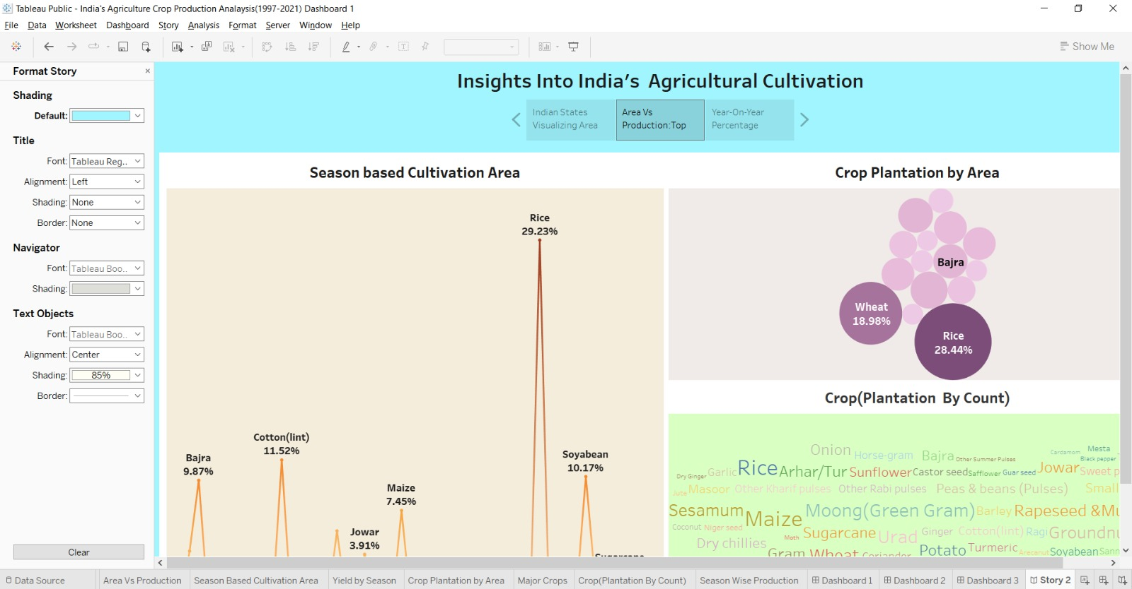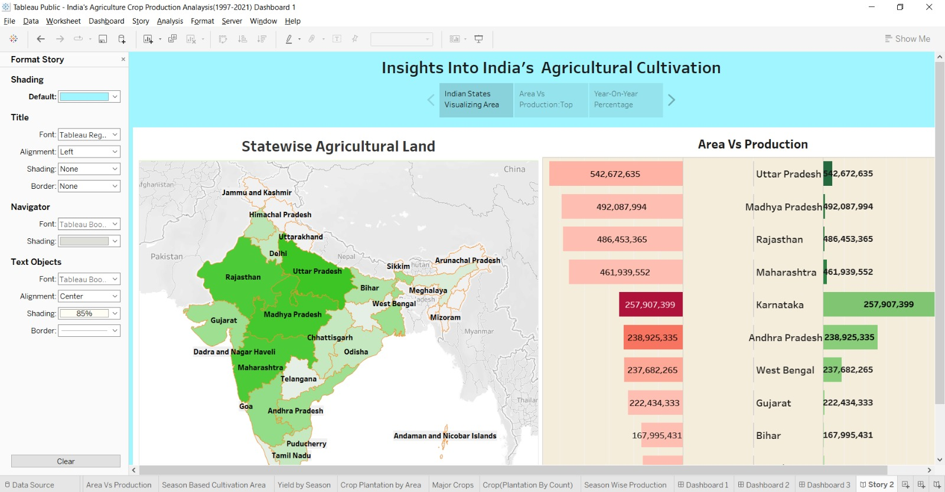

4.ADVANTAGE & DISADVANTAGES

ADVANTAGES

Agriculture supplies raw materials to various agro-based industries like sugar, jute and cotton textile. supporting livelihoods through food, habitat, jobs; and building strong economies through trade.

DISADVANTAGES

Erosion of soil by heavy rain, floods, insufficient vegetation cover etc., reduces farm productivity.

5.APPLICATIONS

It is the primary activity of the nation. It provides employment opportunity to the rural agricultural as well as non-agricultural labourers. It is the source of food and fodder. It also plays an important role in international business in import and export activities.

6.CONCLUSION

The agricultural sector is of vital importance for the region. It is undergoing a process of transition to a market economy, with substantial changes in the social, legal, structural, productive and supply set-ups, as is the case with all other sectors of the economy.

7.FUTURE SCOPE

Agriculture is good for the future as it is expected to use advanced technologies and innovations to produce more food with limited land and resources, increase efficiency on farms, and become more profitable, efficient, safe, and environment friendly.